
CpE-371: SOFTWARE ENGINEERING AND DEVELOPMENT



<AMA-PLATFORM>
Software Requirements Specification (SRS)

Version | v0.2
Status | Draft
Date | 24/10/2026
Prepared by | Abdulrahman Bin Bahar, 2221130212

Department of Computer Engineering
College of Engineering and Petroleum
Kuwait University
20xx - 20xx

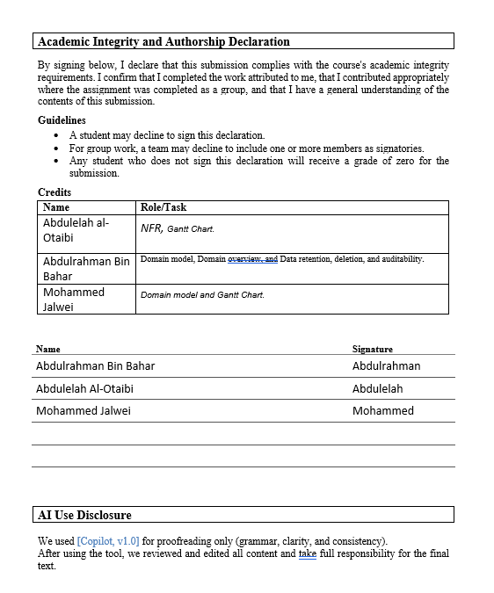

Signature Page

I did my share of the work, and I have a general understanding of the contents of the assignment
Name Signature
Abdulrahman Bin Bahar Abdulrahman
Abdulelah Al-Otaibi Abdulelah
Mohammed Jalwei Mohammed

Report Evaluation
Criterion | Evidence / focus | Weight | Marks | Comments
Document control & professionalism | Version history, ownership, formatting, completeness | 5
Introduction & project framing | Purpose, scope, vision, constraints, assumptions, stakeholders | 10
Functional requirements | Clear, grouped, numbered, testable 'shall' statements | 15
Use-case model | Diagram, actors, use-case specs, traceability, coverage | 15
Non-functional requirements | Measurable NFRs with verification method | 10
Domain / data model | Domain overview, ERD/model, retention/deletion/auditability | 10
UI prototype & usability | Scenario coverage, key screens, findings, updates | 10
Project management & evidence | WBS, Gantt, refs, repo links, meeting records | 5
Team Deliverable Quality (Total) |  |  |  | out of 80
Individual Grade (20%)
Student name | Avg peer score  (/28) | Adjustment | Final mark  (/100) | Notes

Table of Contents
Contents
1
1. Document Control 6
1.1 Version history 6
1.2 Credits 7
1.3 Related documents / links 7
2. Introduction 8
2.1 Purpose 8
2.2 Product vision 8
2.3 Scope 8
2.4 Assumptions and dependencies 8
2.5 Constraints 8
2.6 Stakeholder summary 8
2.7 Overview 9
3. Functional Requirements and Use-case Model 9
3.1 Functional requirements 9
3.2 Use Case Model 9
4. Non-functional Requirements 10
5. Domain overview 11
5.2 Entity-relationship diagram (ERD) / domain model 12
5.3 Data retention, deletion, and auditability 12
6. UI Prototype and Usability Evaluation 12
6.1 Prototype link(s) 13
6.2 Key screens and states 13
6.3 Usability evaluation 14
7. Appendix 14
7.1 References 14
7.2 Project Management 14
Work Breakdown Structure 14
Gantt Chart 15
Team Meetings 15

List of Abbreviations
Abbreviation | Meaning
WBS | Work Breakdown Structure
UC | Use Case
FR | Functional Requirement
SRS | Software Requirements Specification
ERD | Entity-Relationship Diagram
UI | User Interface
NFR | Non-functional Requirement
KPI | Key Performance Indicator

Glossary

Student | A user who is searching for a suitable tutor and requests a tutoring session.
availability | The time slots of the tutor’s when he is available and giving sessions.
tutor | A user who his job is to provide a tutoring session.
Coordinator | A user who is responsible for coordinating between student and tutor and he is the one who manages bookings.
Booking | A tutoring session that has been scheduled and confirmed.

1. Document Control

1.1 Version history
Version | Date | Author | Change summary | Approval
0.1 | 22/10/2026 | Abdulrahman | Domain overview, domain model, and Data retention, deletion, and auditability. | Pending
0.4 | 22/10/2026 | Abdulelah | NFR and Gantte. | Pending
0.7 | 22/10/2026 | Mohammed | domain model and Gantte. | Pending
1.0 | 24/10/2026 | Team | Approved release | Approved by team members

1.2 Credits
Name | Role/Task
Abdulrahman Bin Bahar | retention, deletion, and auditability.
Abdulelah Al-Otaibi | NFR and Gantte.
Mohammed Jalwei | domain model and Gantte.

1.3 Related documents / links
- https://github.com/bhr992/Group-project.git

2. Introduction

2.1 Purpose
[Describe why this SRS exists and who it is for. 3–6 sentences.]

2.2 Product vision
[Describe the user problem and the high-level value proposition.]

2.3 Scope
[Describe the in scope:
- [Feature/Capability 1]
- [Feature/Capability 2]
Out of scope / non-goals:
- [Explicit non-goal 1]
- [Explicit non-goal 2]
]

2.4 Assumptions and dependencies
- Assumption: [e.g., users have verified email addresses]
- Dependency: [e.g., third-party payment provider]

2.5 Constraints
[Describe the relevant constraints]
- [Regulatory / policy constraints]
- [Technology / platform constraints]
- [Operational constraints (e.g., deployment environment)]

2.6 Stakeholder summary
Role | Primary goals | Key needs / pain points | Priority (H/M/L)
[User/Stakeholder role] | [Goal(s)] | [Needs/pain points] | [H/M/L]
[User/Stakeholder role] | [Goal(s)] | [Needs/pain points] | [H/M/L]
[User/Stakeholder role] | [Goal(s)] | [Needs/pain points] | [H/M/L]
[User/Stakeholder role] | [Goal(s)] | [Needs/pain points] | [H/M/L]

2.7 Overview
[Describe what the rest of the SRS document contains, and explain how it is organized.]

3. Functional Requirements and Use-case Model

3.1 Functional requirements
FR-01: [Module / Feature Group Name]
1.1 [Sub-requirement title]: The system shall [specific function].
1.2 [Sub-requirement title]: The system shall [specific function].
1.3 [Sub-requirement title]: The system shall [specific function].
FR-02: [Module / Feature Group Name]
2.1 [Sub-requirement title]: The system shall [specific function].
2.2 [Sub-requirement title]: The system shall [specific function].
2.3 [Sub-requirement title]: The system shall [specific function].
FR-03: [Module / Feature Group Name]
3.1 [Sub-requirement title]: The system shall [specific function].
3.2 [Sub-requirement title]: The system shall [specific function].

3.2 Use Case Model
[Describe functional aspects of the system using UML use case diagram(s). Use Case Diagrams identify actors and use cases. They also describe how the actors interact with the system and the relationships between use cases. .

Draw the use case diagram, then for each use case in your diagram provide a corresponding textual specification. Follow the use case template given below. The use case model shall cover a number of main use cases equal to the number of team members (i.e. 3-member teams shall cover 3 use main cases, 4-member teams shall cover 4 main use cases, 5-member teams shall cover 5 main use cases, and 6-member teams shall cover 6 main use cases). Default use cases like login and create an account are not considered main use cases (i.e. you need to provide the required number of main use cases in addition to any needed default use cases)]
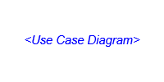
Figure 1 Use Case Diagram

Use case UC- #: Use case name
Related Requirements | List the requirements that are addressed by this use case
Description (Goal) | Informal description of the primary actor(s)’s goal
Primary Actor(s) | Actor(s) who initiates interaction with the system to accomplish a goal
Secondary Actor(s) | Actor(s) who will help achieve the goal or need
Preconditions | What is assumed about the state of the system before the interaction starts
Post-conditions | What are the results after the goal is achieved or abandoned; i.e., what  must be true about the system at the time the execution of this use case is  completed
Related use cases
Basic Flow | Flow of Events for Main Success Scenario
Alternative Flow | Alternate scenarios or extensions in a use case can result from inappropriate data entry

4. Non-functional Requirements
NFR1: Performance
NFR-1.01: The system shall load the login page within 3 seconds in at least 95% of requests.
NFR-1.02: The system shall load the main menu page within 3 seconds in at least 95% of requests.
NFR-1.03: The system shall return tutor search results within 2 seconds in at least 95% of searches.
NFR-1.04: The system shall load the session request page within 2 seconds in at least 97% of requests.
NFR-1.05: The system shall load the user profile page within 2 seconds in at least 95% of requests.
NFR-1.06: The system shall load the dispute review page within 2 seconds in at least 95% of requests.
NFR2: Usability
NFR-2.01: First-time students, tutors, and coordinators shall be able to log in within 3 minutes.
NFR-2.02: First-time students shall be able to submit their first tutoring session request within 2 minutes of opening the session request form.
NFR-2.03: First-time students and tutors shall be able to complete a session rescheduling within 2.5 minutes.
NFR-2.04: First-time students and tutors shall be able to complete a session cancellation within 3 minutes.
NFR-2.05: First-time tutors shall be able to publish a subject, topic, and available session times within 3 minutes.
NFR-2.06: First-time coordinators shall be able to review and approve or reject an exception request within 3 minutes.
NFR3: Security
NFR-3.01: The system shall store user passwords as hashed symbols not store passwords in plain text.
NFR-3.02: The system shall require users to verify their identity using a verification code sent to their registered university email in their first login.
NFR-3.03: The system shall require users to provide their registered email address and password when logging in.
NFR-3.04: The system shall allow students to access only their own personal information and session records.
NFR-3.05: The system shall allow tutors to access only the student information and session records necessary for sessions requested with them.
NFR-3.06: The system shall restrict coordinators to the information and administrative functions permitted by their only assigned roles.
NFR4: Availability
NFR-4.01: The system shall maintain at least 99% availability during service period, no included maintenance plan.
NFR-4.02: The system shall notify users in advance of scheduled maintenance that may affect system availability.

5. Domain overview
The AMA-Platform domain focuses on the lifecycle of a tutoring session. Students can submit multiple session requests and choose their preferred tutors. Session requests record and manage tutoring requests submitted by students. Tutors review session requests and decide whether to accept or decline them. Admins manage exceptional cases when necessary. Tutoring sessions are scheduled after approved requests and are attended by students. Notifications are sent to students and tutors with the details of the session.

5.2 Entity-relationship diagram (ERD) / domain model
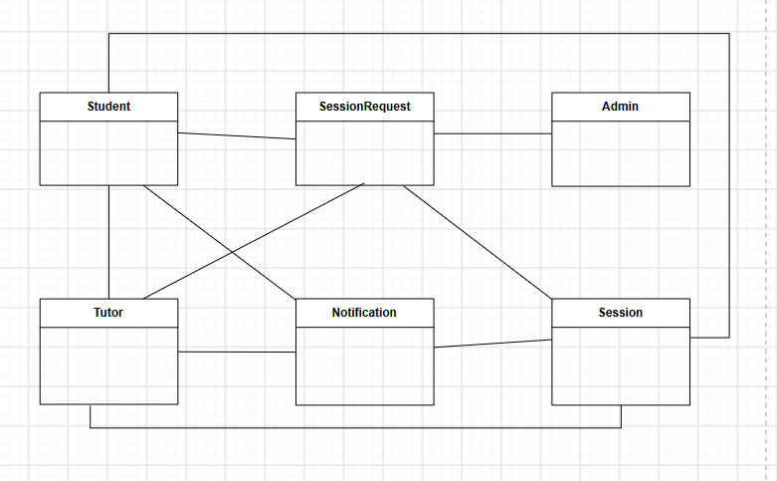
Figure 1. High-level domain model for the AMAPLATFORM (missing multiplicity and attributes)

5.3 Data retention, deletion, and auditability
- Retention: Session requests, sessions, notifications data should be retained for at least 1 year for operational reporting and dispute handling.
- Retention: security and administrative audit logs should be retained for a minimum of 150 days.
- Deletion: Users who remain inactive for one week shall receive a warning notification. If no activity is detected after the warning, the account may be deleted by the system.
- Auditability: All session requests and tutoring sessions should be traceable, including details such as the timestamp and the user who performed the action.

6. UI Prototype and Usability Evaluation
If the product is UI-heavy, include a prototype and a brief evaluation to reduce ambiguity and rework.
[Create a UI prototype covering a scenario for each main use case (e.g. if you have 3 main use cases, cover 3 scenarios, and so on) using Invision app. Create the screens using some proper software tool then connect them on Invision app. Make sure to show data in the scenarios (e.g. in case of a login form show it first empty then when the user clicks on it show the data filled in the fields).]
The goal of this prototype is elicit requirement from the customer using prototyping based on scenarios from the requirement specifications. This prototype is be able to handle < your number of main use cases > scenarios. It was tested on [3] users.

6.1 Prototype link(s)
- Figma / prototype: [link]

6.2 Key screens and states
[Create a prototype of your system on invision app covering the < your number of main use cases > chosen scenarios. Create the screens using proper software tools then connect them on Invision app. Make sure to show data in the scenarios. Include the invision app link here. In addition, describe your preliminary design by presenting pictures of important screens and briefly explaining the function of each screen.]
This section of the document contains brief descriptions of the main screens in <name of your application>. Each screen in the system shows the behavior and state changes that the user will experience when pressing a button or choosing an option on the screen. InVision App online prototyping tool was used to create all of the system screens. The UI interactive prototype is available online at this <your invision app link>.

- ……… Screen (e.g. Login Screen)
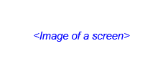
Figure 2 .... Screen
Description: …………………………………………………………………..

- ……… Screen

Figure 3 ..... Screen
Description: …………………………………………………………………..

6.3 Usability evaluation
Scenario ID | Scenario | Participants | Findings | Action / requirement update
UE-0X | [User tries to …] | [N users, profile] | [What worked / what failed] | [Change to story/NFR/UI]
UE-0X | [User tries to …] | [N users, profile] | [What worked / what failed] | [Change to story/NFR/UI]
UE-0X | [User tries to …] | [N users, profile] | [What worked / what failed] | [Change to story/NFR/UI]
UE-0X | [User tries to …] | [N users, profile] | [What worked / what failed] | [Change to story/NFR/UI]

7. Appendix

7.1 References
- Course notes, lecture slides, and instructor feedback for CpE-371 Software Engineering and Development.

7.2 Project Management

Work Breakdown Structure
ID | Task name | Duration | Start | Finish | Pred. | Resources
1 | Project proposal | 6 d | 2026-10-16 | 2026-10-21 | - | Team
2 | Requirements elicitation | 6 d | 2026-10-16 | 2026-10-21 | 1 | Mohammed, Abdulelah
3 | SRS drafting | 26 d | 2026-10-22 | 2026-11-16 | - | Team
4 | Use case and domain modeling | 6 d | 2026-10-22 | 2026-10-27 | 2 | Abdulelah
5 | UI prototyping | 7 d | 2026-10-28 | 2026-11-03 | 3,4 | Team
6 | Usability testing | 4 d | 2026-11-04 | 2026-11-07 | 5 | Team
7 | Design revision | 4 d | 2026-11-08 | 2026-11-11 | 6 | Team
8 | Implementation planning | 5 d | 2026-11-12 | 2026-11-16 | 7 | Abdulrahman
9 | Final review & submission | 5 d | 2026-11-16 | 2026-11-16 | 8 | Team

Gantt Chart
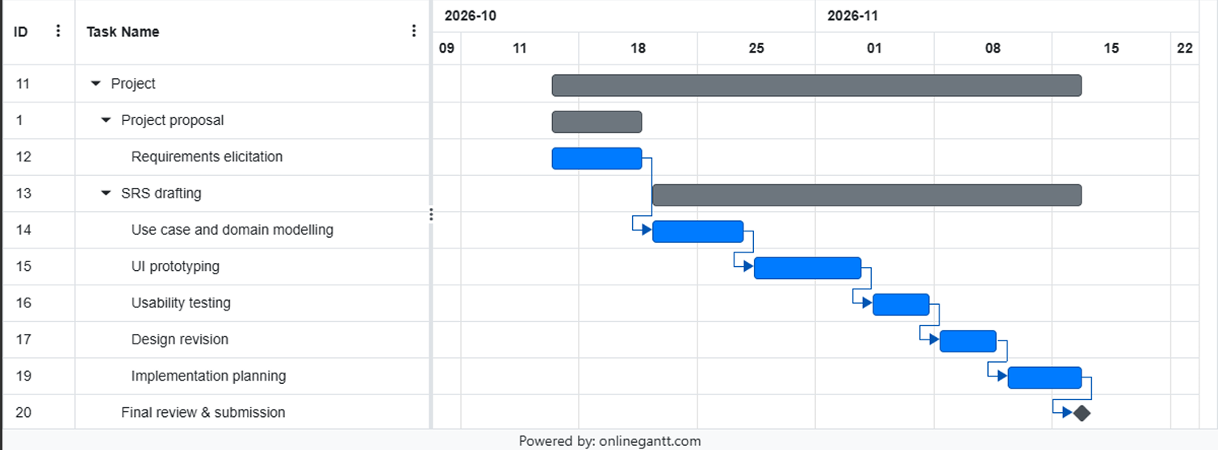
Repository link: https://github.com/bhr992/Group-project.git

Team Meetings
Meeting | Date | Attendees | Main outcome | Minutes link
M1 | 5/10/2026 | All team members | Confirmed project scope, stakeholder list, and initial assumptions. | https://github.com/bhr992/Group-project.git
M2 | 15/10/2026 | All team members | Reviewed functional requirements and main use cases, create the chart | https://github.com/bhr992/Group-project.git
M3 | 22/10/2026 | All team members | Reviewed non-functional requirements , Domain overview, Entity-relationship diagram (ERD) / domain model, and Data retention, deletion, and auditability. | https://github.com/bhr992/Group-project.git

